Download JMeter
Site: https://jmeter.apache.org/download_jmeter.cgi
For Windows Download this:
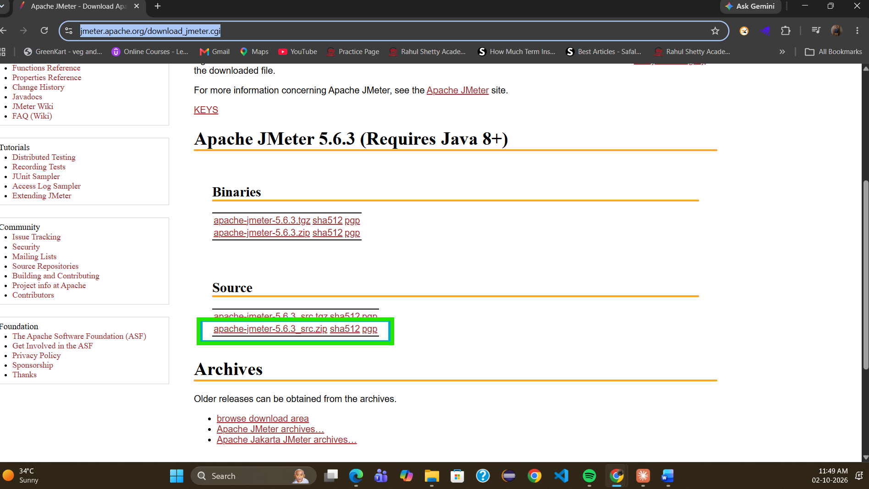

You Need Java as Well
Download JDK: https://www.oracle.com/in/java/technologies/downloads/#java27
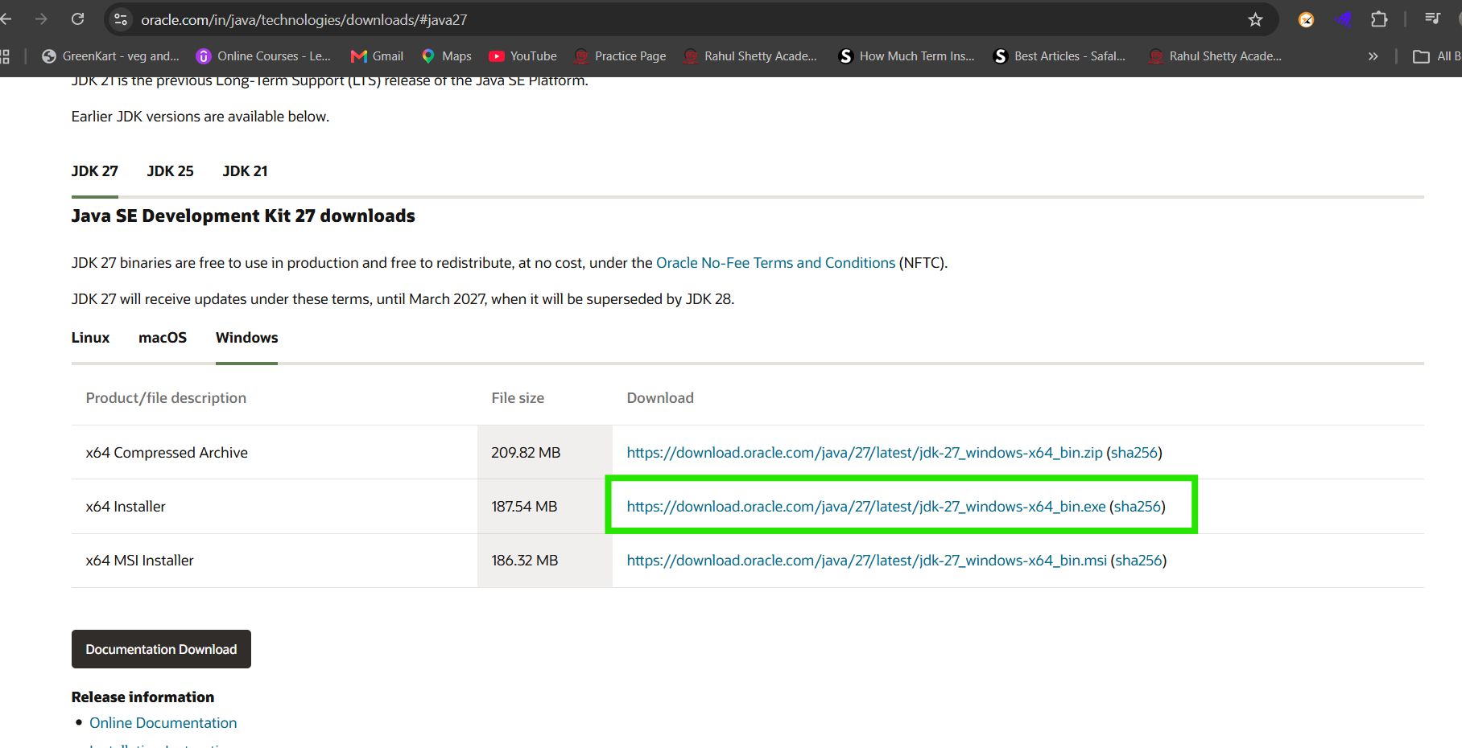

Open the JMeter from folder
Extract the JMeter folder and go in bin and double click on JMeter logo file
File is already extracted and save in D folder
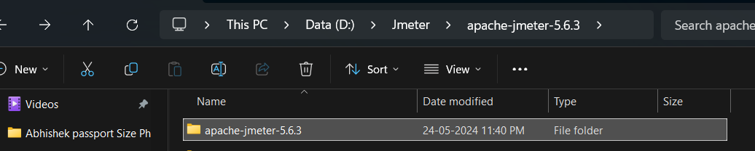
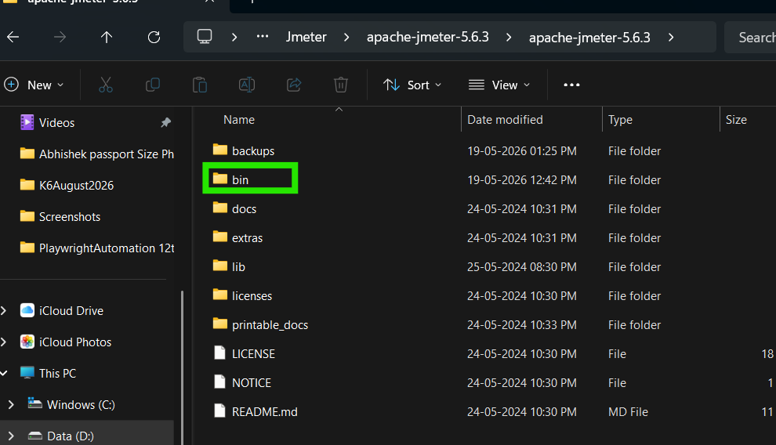
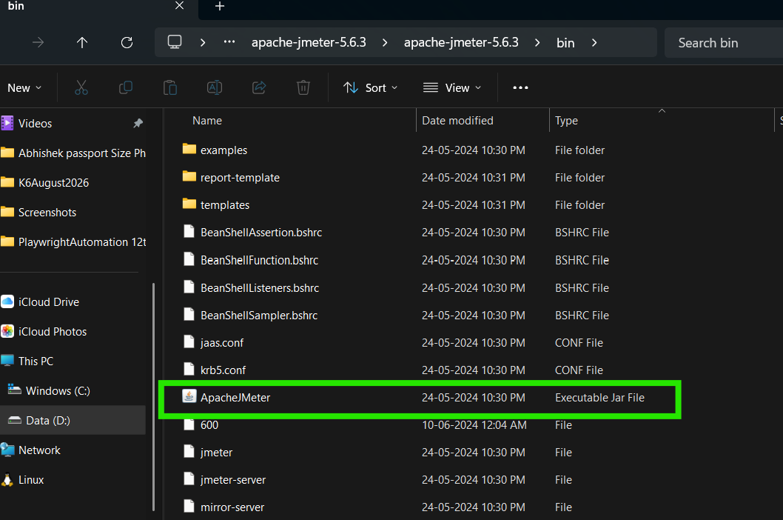

What is Test Plane
In JMeter, a Test Plan is the main container for your entire performance test.
Think of it like this:
🏠 Test Plan = House
├── 👥 Thread Group = Users
├── 🌐 HTTP Request = Actions users perform
├── 🔍 Listener = Results/report
└── ⚙️ Config Elements = Common settings

What are Threads, Listeners & Assertions in JMeter

🧑‍💻 Threads — Virtual Users
In JMeter, a Thread represents a virtual user.
For example, suppose you want to test a login page with 100 users.
You configure:
- Number of Threads = 100
- Ramp-up = 10 seconds
JMeter will create 100 virtual users and gradually start them over 10 seconds.

👀 Listeners — See the Results
A Listener is used to view and analyze the results of your JMeter test.
For example:
- View response time
- See requests passed/failed
- Check throughput
- See response data
- Analyze errors

✅ Assertions — Check Whether the Response Is Correct
An Assertion is a checkpoint in JMeter.
It tells JMeter:
"I received a response, but now check whether the response is actually what I expected."
Think of it like a QA tester manually checking an API response.

To start with Recording in JMeter using Firefox
First set proxy in Firefox browser

